Potential joint Op-ed/Position paper:

Reinforcing the Foundations of Australia’s Future Through Mathematics Education

Australia is at a crossroads in mathematics education, with the decline in secondary and tertiary teaching and learning in this fundamental discipline risking our future capacity for innovation, economic competitiveness, and security. The potential impact of this quiet crisis on the STEM workforce has been highlighted by experts including Australia’s former Chief Scientists, Dr Cathy Foley and Professor Alan Finkel.

A numerate and scientifically literate workforce is essential for harnessing technological opportunities such as Artificial Intelligence, addressing global challenges such as climate change, food security, energy transitions, and safeguarding our nation against a variety of threats. This concern also directly aligns with reforms identified by the Productivity Commission, with Prime Minister Albanese and Treasurer Chalmers recently reaffirming productivity growth as a key priority for the government. Our ability to deliver this workforce depends on mathematics education in secondary school and university. This issue is particularly important currently because STEM jobs are increasing at twice the rate of non-STEM jobs, and shortages in numerate graduates are predicted to grow to daunting levels over the next decade.

Mathematics is a foundational discipline that enables applied STEM disciplines such as information and communications technology (ICT), engineering, health, environmental science, and physical and life sciences. It is also critical to non-STEM fields including business, economics and logistics, as well as to national defence capabilities, and is therefore important to innovation and addressing global challenges. A mathematically literate population is essential. The importance of mathematics learning spans the educational pipeline—from primary and secondary school through vocational training and/or university undergraduate and graduate studies, and into the broader workforce. And yet, the number of secondary school students studying ‘higher’ and ‘intermediate’ mathematics has experienced long-term decline (Marchant and Kennedy 2024 – see footnote). Compounding this issue, to increase access few universities now require intermediate or sometimes any mathematics as prerequisite for science and engineering degrees, with the unfortunate consequence of reducing the incentive for secondary students to study mathematics.

There are many other factors contributing to the decline in students studying mathematics at school and in university, ranging from a shortage of mathematics teachers, limited professional development opportunities for teachers or time to engage in existing programs, and uncertainties regarding potential career opportunities for students who study mathematics.

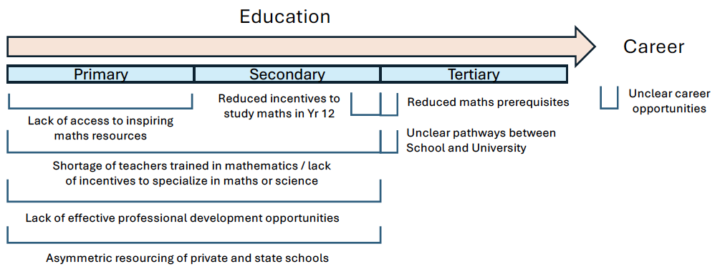
These issues are summarised in the diagram below.

Compounding these challenges is the fact that 40% of mathematics teachers in Australia are ‘out-of-field,’ teaching without formal mathematics qualifications —arguably the most critical issue, given teaching outcomes compound across all latter stages of education. While some states have introduced upskilling programs, their scale is too small to address the national problem. The government’s National Teacher Workforce Action Plan includes initiatives to improve teacher supply and retention. Making STEM teaching an attractive and well-supported career is critical to reversing the downward spiral, where declining graduate numbers exacerbate shortages in qualified educators. However, it must also prioritise targeted, coordinated upskilling for out-of-field teachers if mathematics education in Australia is to remain robust. Such upskilling has been proposed by the Australian Mathematical Sciences Institute (AMSI). While some jurisdictions are making significant efforts to create capacity for such development activities, for example by reducing the administrative burdens and high workloads on teachers, we need stronger, nationally coordinated incentives for teachers to take advantage of upskilling programs.

We are a coalition of university thought leaders committed to educating Australians and ensuring a strong pipeline of STEM-skilled professionals to tackle the nation’s most complex challenges. We advocate for a comprehensive strategy focused on:
- Igniting interest in mathematics from the early years of education, across culturally, linguistically, and economically diverse students.
- Showcasing the value of mathematics to secondary students by linking critical thinking skills to real-world problem-solving.
- Encouraging future high school teachers to specialise in science or maths during their training, while providing nationally coordinated professional development to support out-of-field mathematics teachers, in alignment with AMSI proposals.
Furthermore, and as noted above, although the move by some universities to drop or reduce mathematics prerequisites for key undergraduate courses (e.g. Science and Engineering) may seem like a reasonable response to current challenges in high school mathematics, it risks reducing the incentive to study mathematics in secondary school. While alternate pathways are important, the most efficient and equitable way to ensure STEM readiness is to strengthen mathematics education within the secondary system itself. Indeed, lowering the bar does not elevate our students; instead, it diminishes the value of maths and drives attrition in future years. Higher education policy and university admissions criteria must reinforce the importance of mathematics and not diminish its value.

While our recommendations below focus on senior secondary and university levels, equally profound impacts will come from supporting mathematics teaching in primary and lower secondary schools.

Our call to action
Universities play an important role in addressing this challenge, particularly through admissions policies and incentives to encourage Year 11 and 12 students to study mathematics. To ensure Australia remains competitive, innovative, and prosperous, we call for:
- Incentives: Nationally coordinated, funded initiatives to boost Year 11 and 12 mathematics enrolments — tackling mathematics anxiety, addressing gender gaps by promoting female role models, and clearly linking mathematics study to diverse career pathways.
- Pathways: Well-funded, affordable sub-bachelor programs (diplomas and associate degrees) with national coordination — potentially led by the Australian Tertiary Education Commission — to ensure students without intermediate mathematics can still access STEM degrees.
- Prerequisites: Reinstating intermediate-level mathematics requirements for key university courses to secure student preparedness, while maintaining equity and alternative entry options where needed.
Signed:
[Presidents, ACDS ACED, ACEDD etc etc]

Select references
- Chief Scientists calls on schools to improve science studies, The Australian, November, 2023
- Skills Priority List and Employment Outlook, Jobs and Skills Australia, 2023 and 2022
- Maths Crisis: Year 12 Maths Enrolments Reaches All-time Low, Australian Mathematical Sciences Institute, 2022
- University of Sydney cuts maths prerequisites for many degrees, The Australian, 2024
- Relieving out of field teaching in Australian Secondary Mathematics, Australian Mathematical Sciences Institute, 2024
- Office of the Chief Scientist, 2019: Australian_informed_choices_position_paper.pdf
- The State of Mathematical Sciences 2024: 8th discipline profile of mathematics and statistics in Australia

Different States use varying terminology for mathematics curriculum levels. Here, “Higher” refers to the Australian Curriculum level equivalent to “Specialist Mathematics,” while “Intermediate” aligns with “Mathematical Methods,” as outlined by Marchant and Kennedy (2024) in their Year 12 Mathematics Participation Report Card: Mathematics Enrolments Remain at All-Time Lows (available at https://amsi.org.au/?publications=year-12-mathematics-participation-report-card-mathematics-enrolments-remain-at-all-time-lows.)
Reviewing Out of field teaching in Australian secondary mathematics: Analysis of out of field secondary mathematics teacher upskilling initiatives in Australia. 2024. Available at https://amsi.org.au/wp-content/uploads/2024/03/maths-ooft-report.pdf. Accessed 11/9/24.

